Ex.no:6 | DATA VISUALIZATION USING POWER BI
Date: | DATA VISUALIZATION USING POWER BI

Aim:
To Load the data into PowerBI and transform the data and visualize it to get insights

Algorithm:
Algorithm 1: Importing Data into Power BI
Step 1
Open Power BI Desktop.
Step 2
Select:
Home → Get Data
Step 3
Choose Excel or CSV according to the dataset format.
Step 4
Browse and select the Retail_Sales dataset.
Step 5
Load the selected dataset into Power BI.
Step 6
Verify the imported dataset in Power BI.
Algorithm 2: Data Transformation using Power Query
Step 1
Select Transform Data to open Power Query Editor.
Step 2
Inspect the Retail_Sales dataset and identify data quality issues.
Step 3
Remove duplicate records from the dataset.
Step 4
Handle null or blank values in relevant columns.
Step 5
Standardize text values such as Region and Product.
Step 6
Verify the data types of numerical and categorical columns.
Step 7
Click Close & Apply to load the transformed data into Power BI.
Algorithm 3: Advanced Data Transformation
Step 1
Select the OrderDate column and examine its date format.
Step 2
Convert the OrderDate values into a consistent date format.
Step 3
Create a new ParsedDate column for standardized date values.
Step 4
Handle inconsistent or invalid date entries.
Step 5
Check the Quantity and Sales columns for invalid or negative values.
Step 6
Apply the required transformations and load the cleaned dataset into the data model.
Algorithm 4: Creating Calculated Column and DAX Measures
Step 1
Select the Retail_Sales table in Power BI.
Step 2
Create a calculated Revenue column using the appropriate DAX formula based on the dataset fields.
Step 3
Create DAX measures for important sales statistics.
Step 4
Calculate Total Sales using the SUM function.
Step 5
Calculate Average Sales, Maximum Sales, and Minimum Sales using appropriate DAX functions.
Step 6
Validate the calculated values and use them in dashboard visuals.
Algorithm 5: Dashboard Visualization and Reporting
Step 1
Create a Bar Chart to visualize sales across different products or product categories.
Step 2
Create a Pie/Donut Chart to represent the distribution of sales across categories.
Step 3
Create Card Visuals to display Total Sales, Average Sales, Maximum Sales, and Minimum Sales.
Step 4
Add a Region Slicer to enable interactive filtering of the dashboard.
Step 5
Add a suitable dashboard title and arrange all visuals neatly.
Step 6
Test the dashboard by selecting different regions and verify that the visuals update dynamically.
Step 7
Save the completed Power BI report as a .pbix file.

Output:

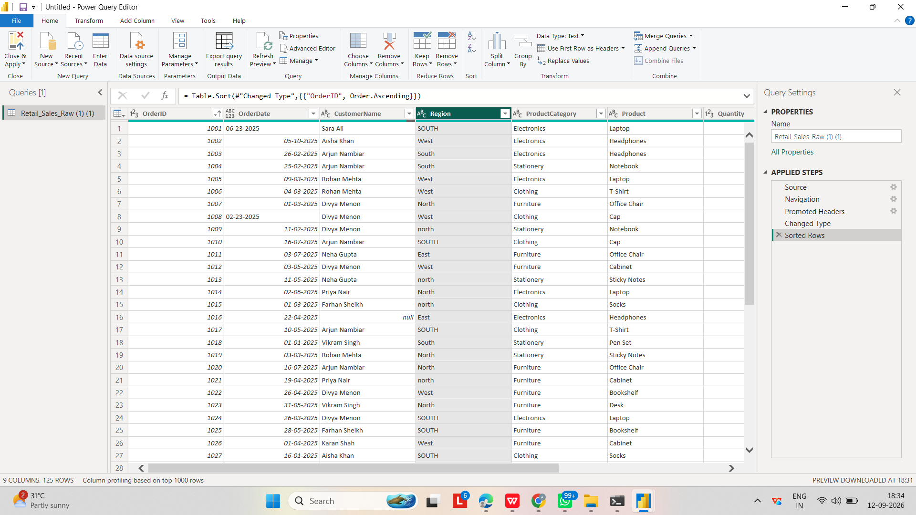

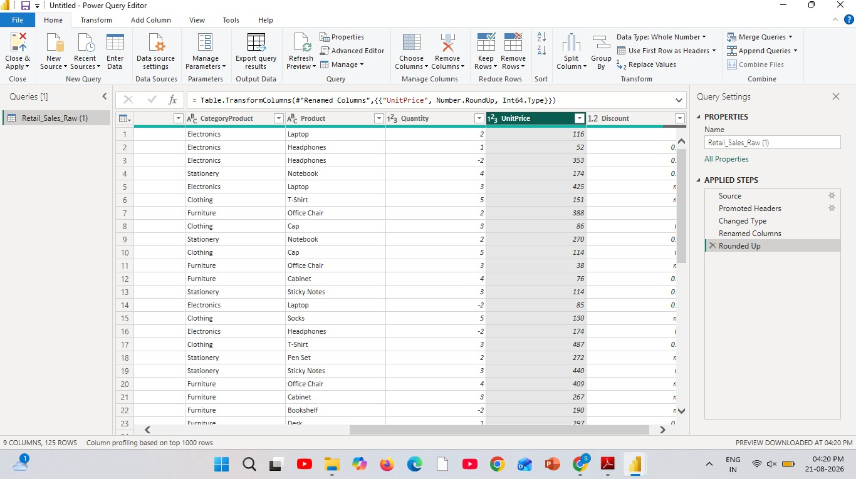
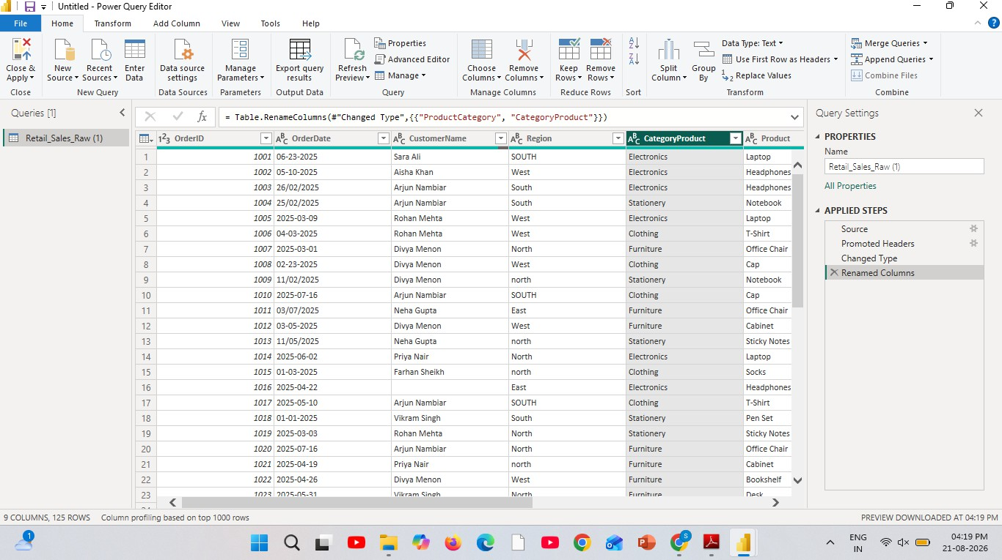

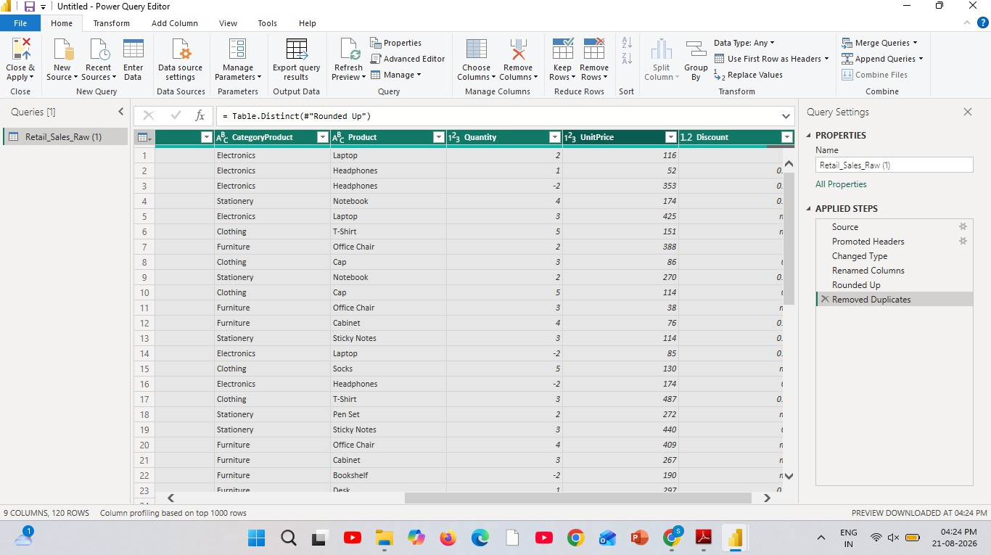

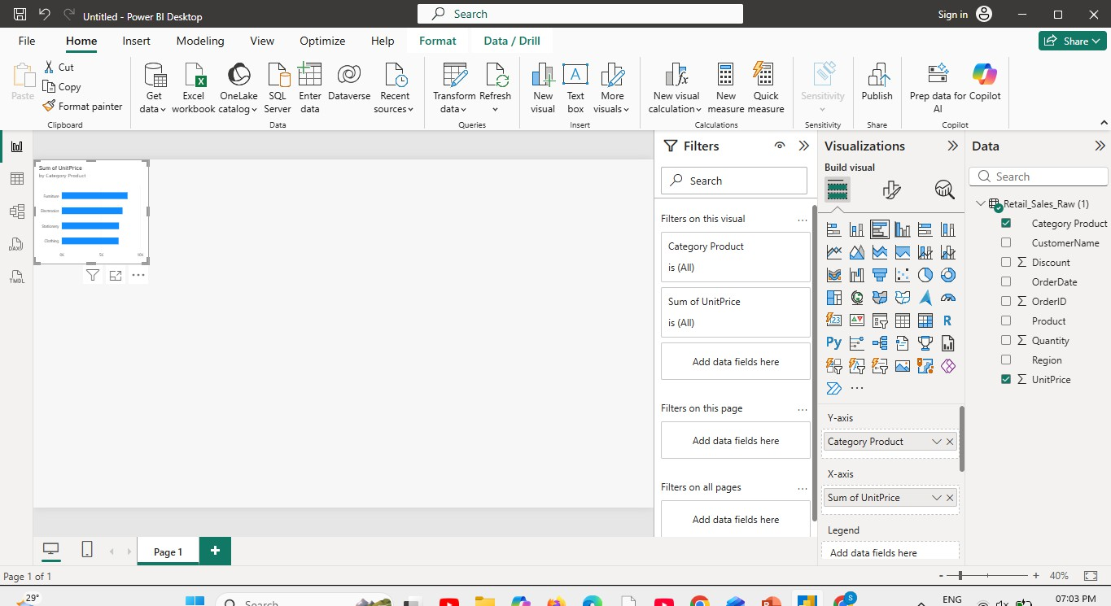

Result:

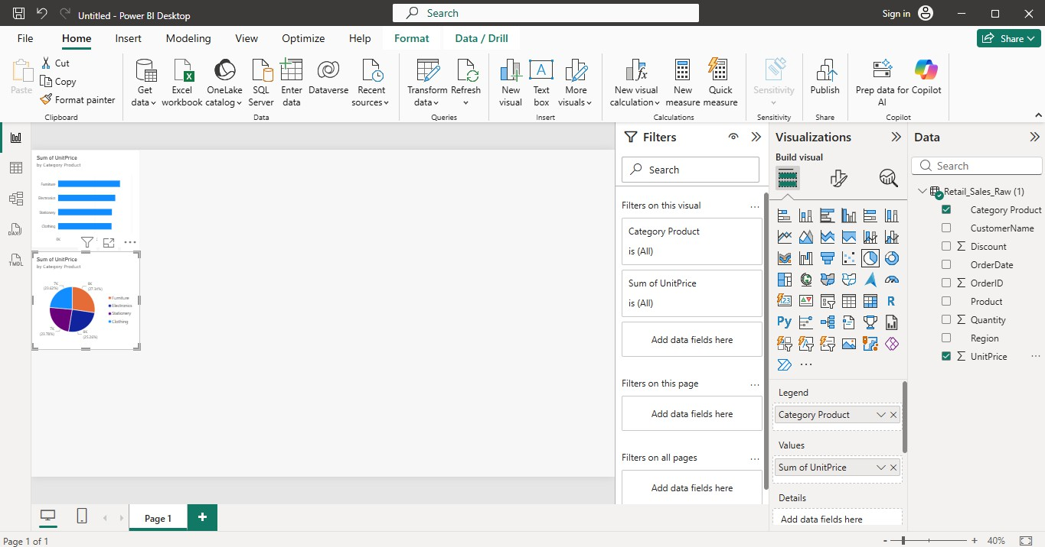

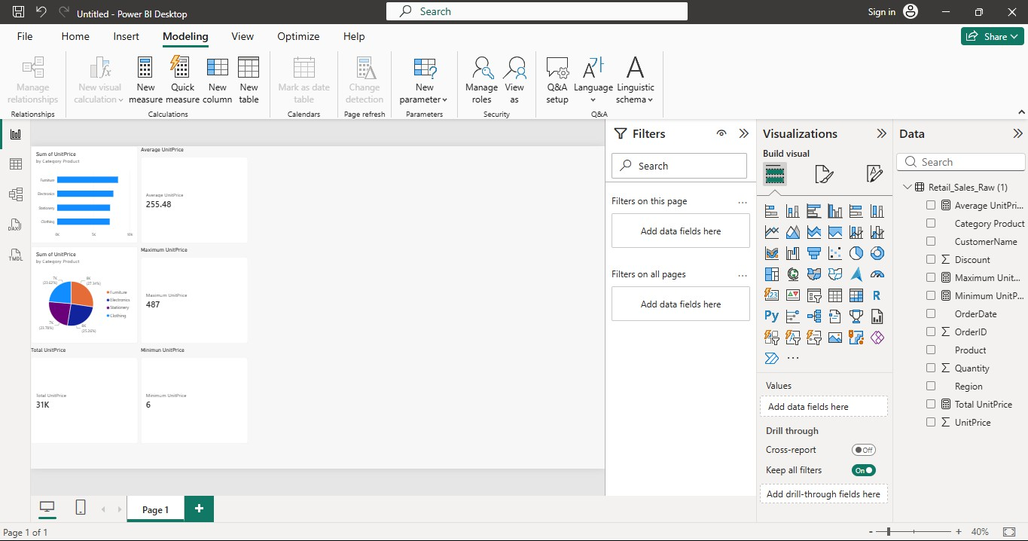

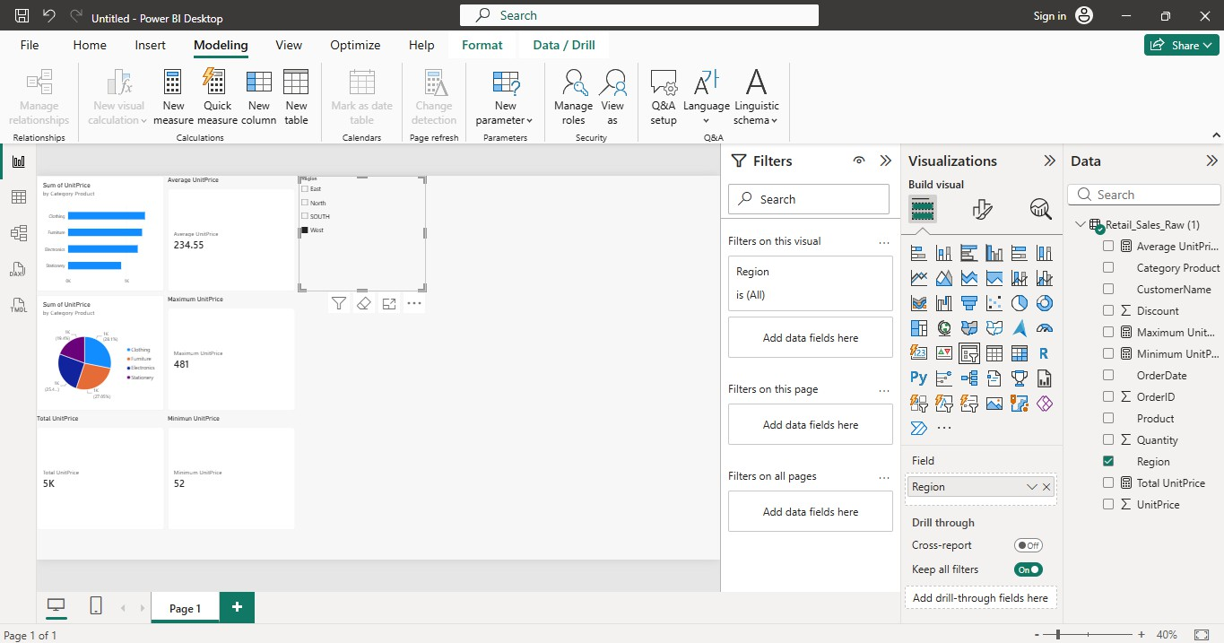

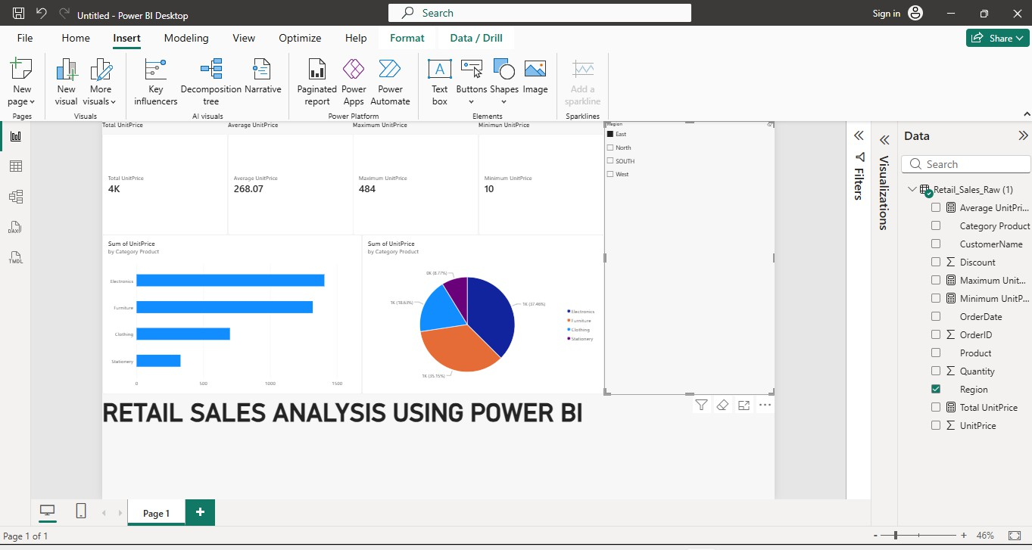

Result:
Thus, the retail sales dataset was successfully loaded into Power BI and visualized using different Power BI visuals. KPI cards were created to display the Total, Average, Maximum, and Minimum Unit Price. A Bar Chart and Pie Chart were used to analyze Unit Price based on Product Category, and a Region slicer was used to interactively filter the dashboard. Hence, meaningful insights were successfully obtained from the retail sales data using Power BI.

